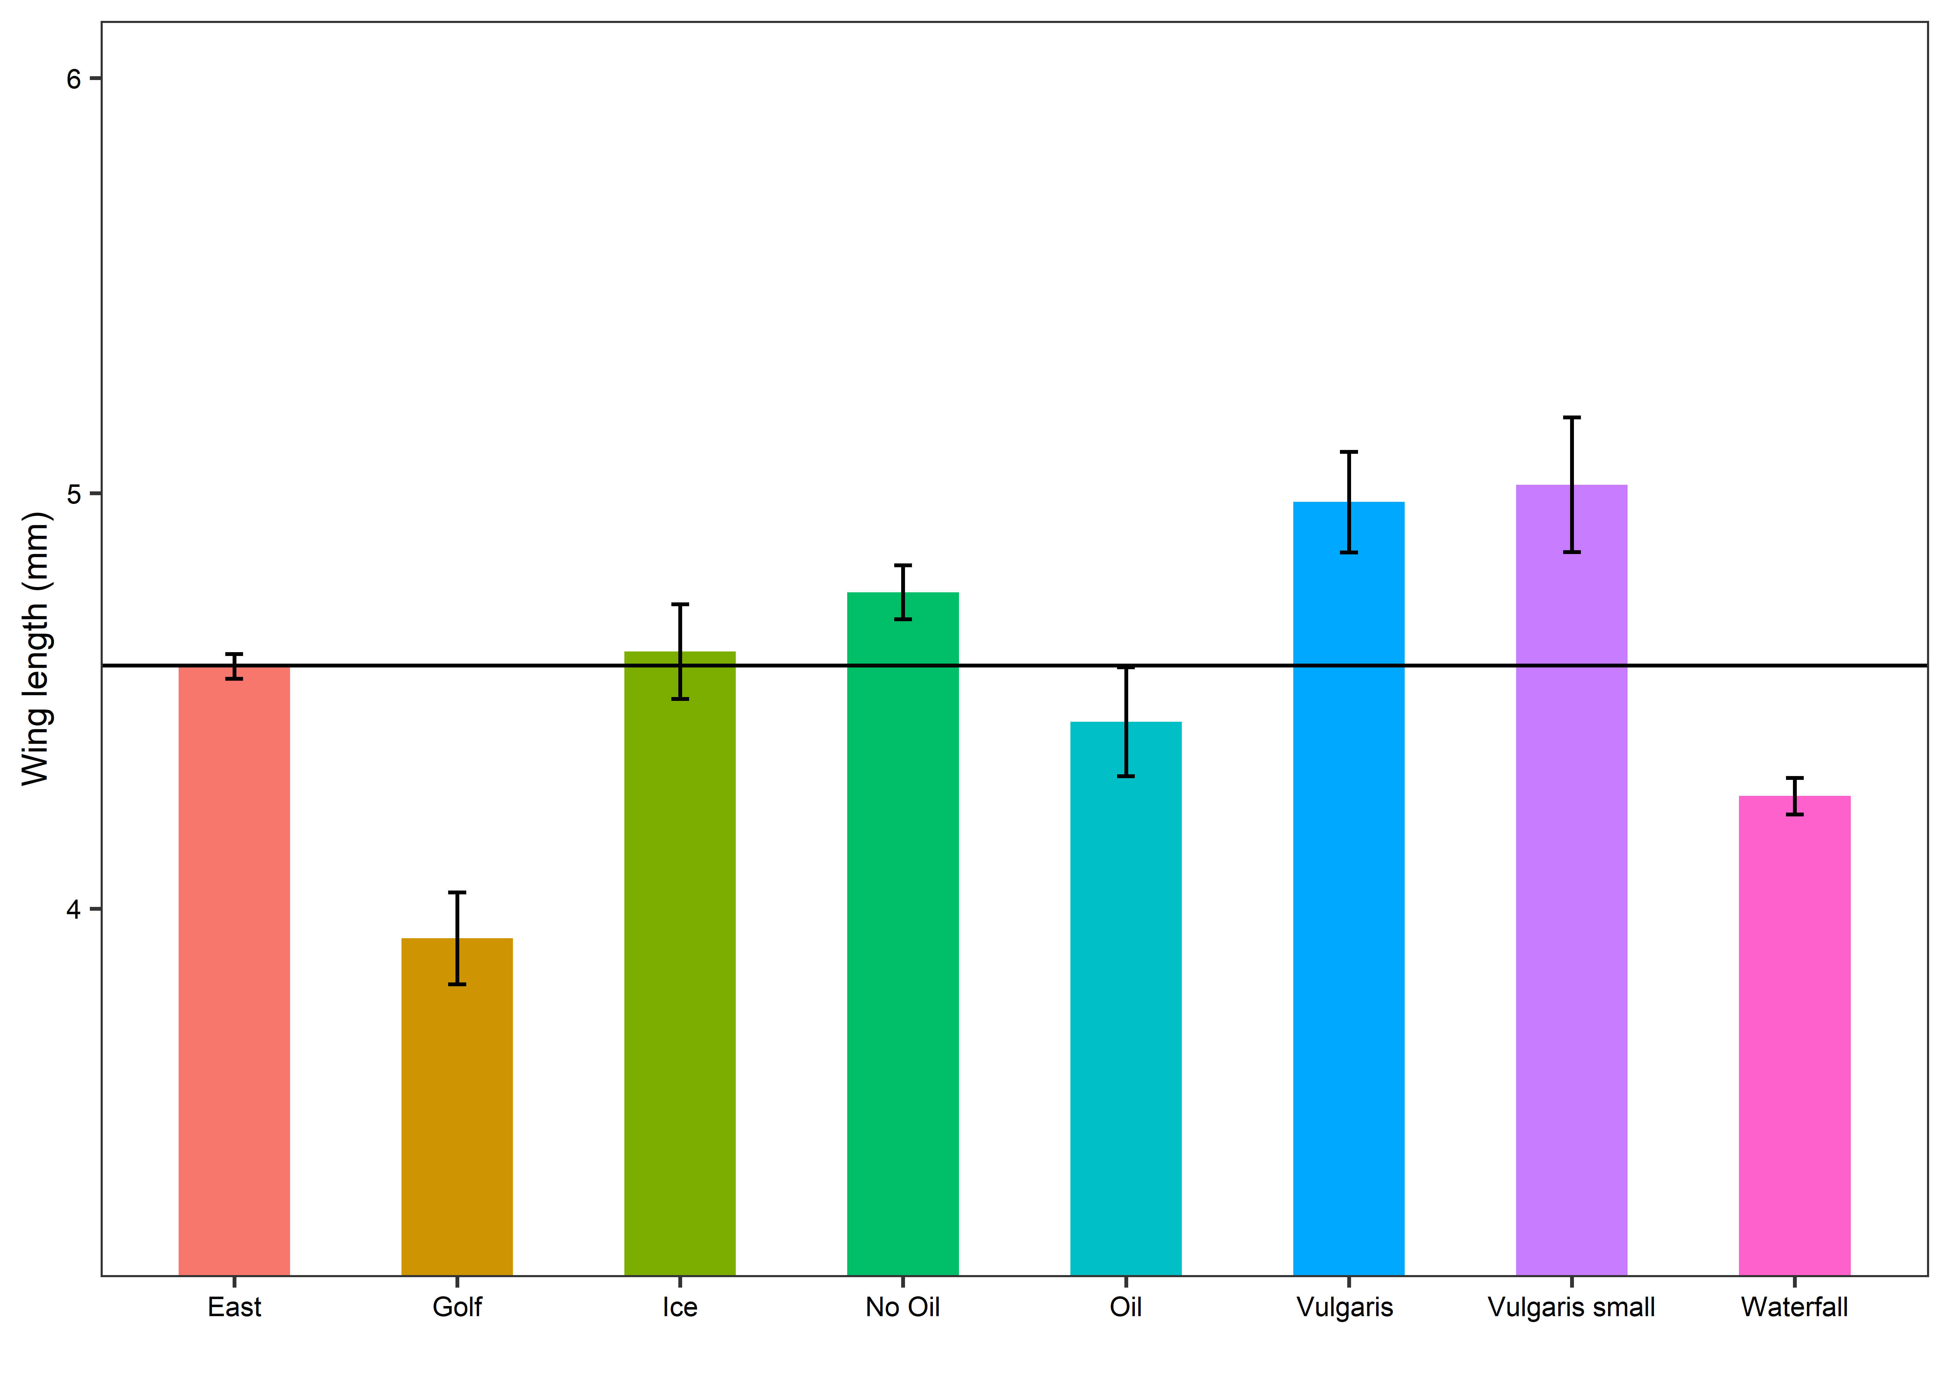

> model1<-aov(Winglenth~Pond, data=DET1)

> summary(model1)

Df Sum Sq Mean Sq F value Pr(>F)

Pond 7 5.870 0.8386 8.071 6.1e-06 \*\*\*

Residuals 37 3.845 0.1039

---

Signif. codes: 0 ‘\*\*\*’ 0.001 ‘\*\*’ 0.01 ‘\*’ 0.05 ‘.’ 0.1 ‘ ’ 1

19 observations deleted due to missingness

Tukey multiple comparisons of means

95% family-wise confidence level

Fit: aov(formula = Winglenth ~ Pond, data = DET1)

$Pond

diff lwr upr p adj

Ice-Golf 0.69047619 0.13732825 1.24362413 0.0062634

No Oil-Golf 0.83333333 0.28018540 1.38648127 0.0005661

Vulgaris -Golf 1.05059524 0.40197179 1.69921869 0.0001891

Vulgaris small-Golf 1.09226190 0.55667872 1.62784509 0.0000030

Vulgaris small-Oil 0.57083333 -0.01911910 1.16078577 0.0639182

Waterfall-Vulgaris -0.70833333 -1.44007927 0.02341261 0.0637216

Waterfall-Vulgaris small -0.75000000 -1.38371057 -0.11628943 0.0110770

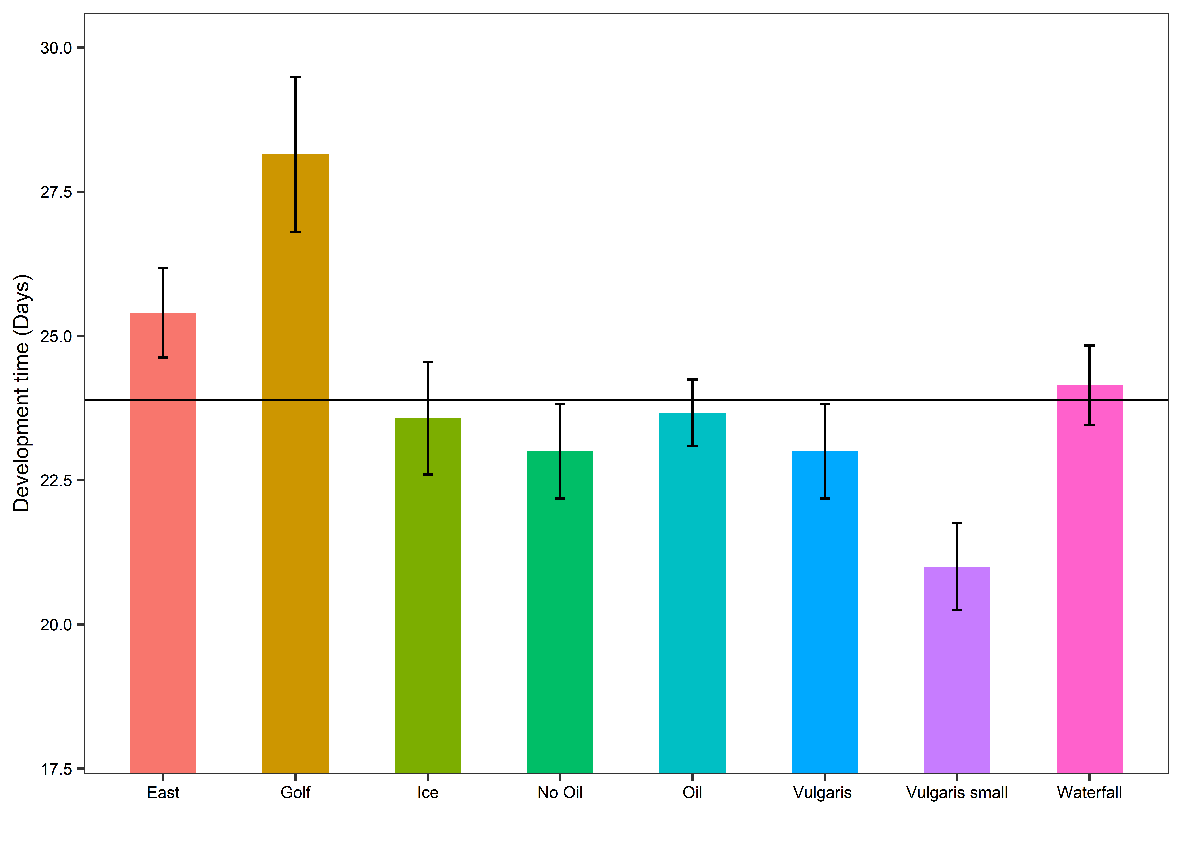

> model2<-aov(daysemerg~Pond, data=DET1)

> summary(model2)

Df Sum Sq Mean Sq F value Pr(>F)

Pond 7 217.4 31.053 5.03 0.000273 \*\*\*

Residuals 46 284.0 6.173

---

Signif. codes: 0 ‘\*\*\*’ 0.001 ‘\*\*’ 0.01 ‘\*’ 0.05 ‘.’ 0.1 ‘ ’ 1

10 observations deleted due to missingness

> TukeyHSD(model2, "Pond")

Tukey multiple comparisons of means

95% family-wise confidence level

Fit: aov(formula = daysemerg ~ Pond, data = DET1)

$Pond

diff lwr upr p adj

Vulgaris small-East -4.400000e+00 -8.8962881 0.09628814 0.0591125

Vulgaris -Golf -5.142857e+00 -9.3586419 -0.92707236 0.0075213

Vulgaris small-Golf -7.142857e+00 -11.2247732 -3.06094108 0.0000349

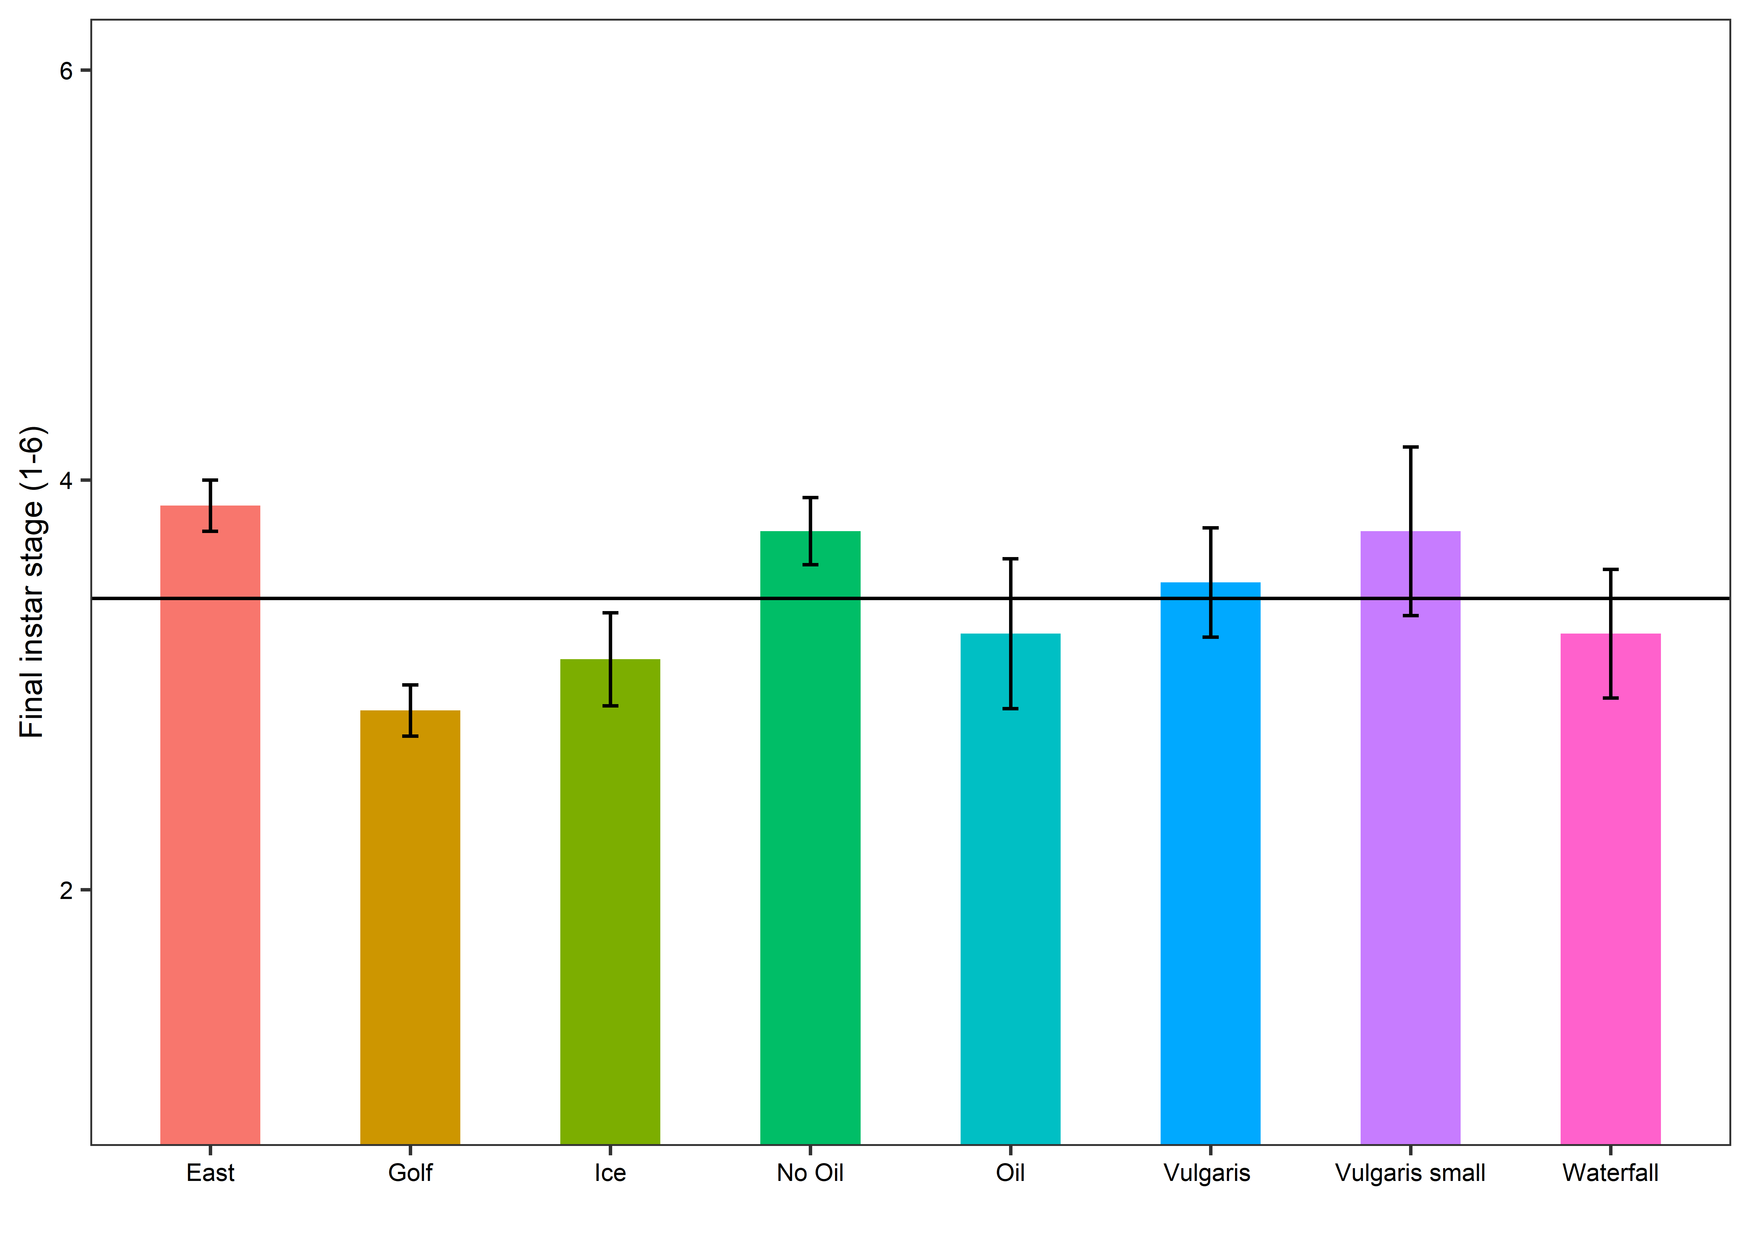

> model4<-aov(finalstage2~Pond, data=FPOM)

> summary(model4)

Df Sum Sq Mean Sq F value Pr(>F)

Pond 7 6.98 0.9978 1.713 0.125

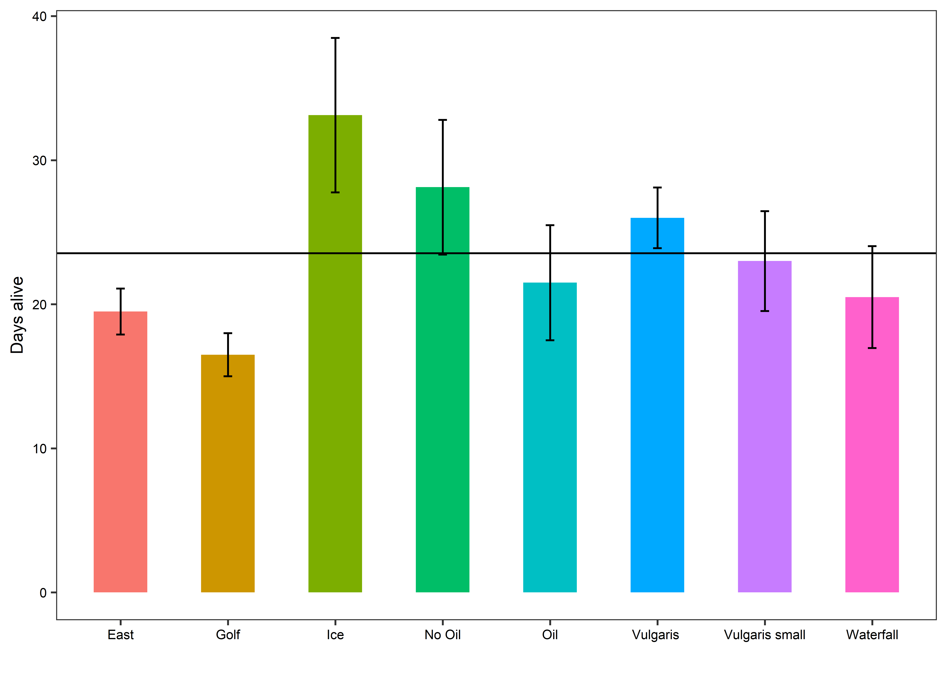

> model3<-aov(daysalive~Pond, data=FPOM)

> summary(model3)

Df Sum Sq Mean Sq F value Pr(>F)

Pond 7 1588 226.8 2.26 0.0427 \*

> TukeyHSD(model3, "Pond")

Tukey multiple comparisons of means

95% family-wise confidence level

Fit: aov(formula = daysalive ~ Pond, data = FPOM)

$Pond

diff lwr upr p adj

Ice-Golf 16.625 0.8444496 32.405550 0.0321423